**Exercise of Databases**

Ques1.Create Database

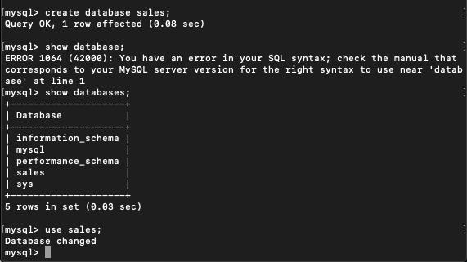

Ques2 Design Schema

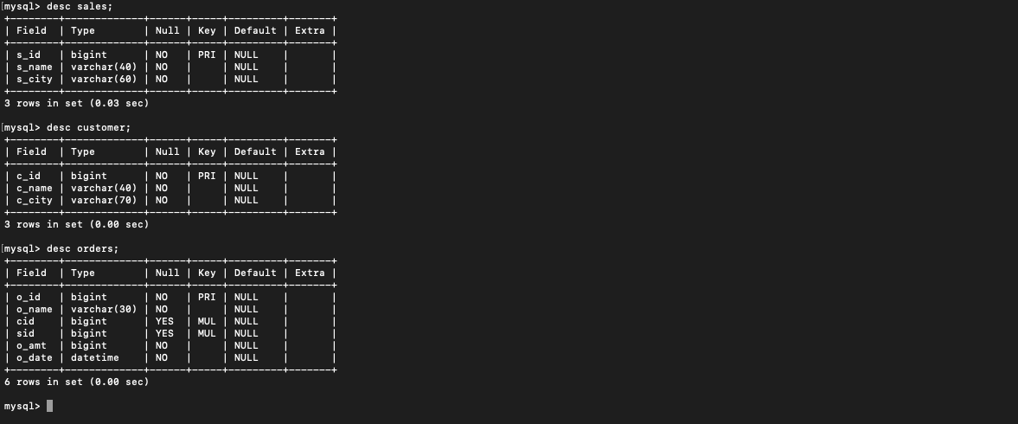

Ques3 Create tables

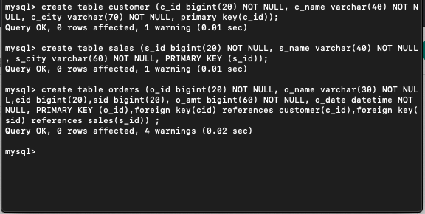

Ques4 Insert sample data

Customer table-

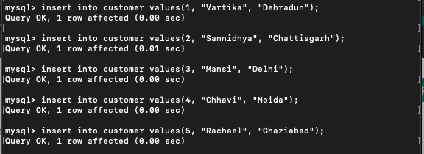

Sales table-

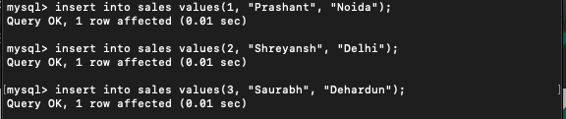

Orders table-

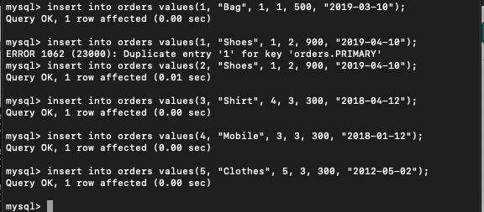

Ques5 Find the sales person have multiple orders.

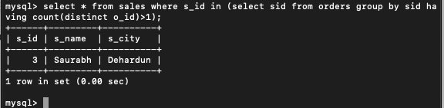

Ques6 Find the all sales person details along with order details

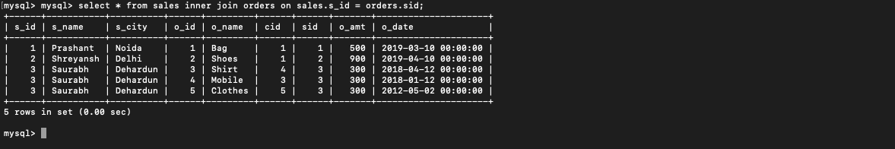

Ques7 Create index

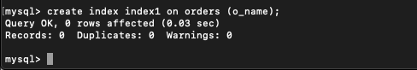

Ques8 How to show index on a table

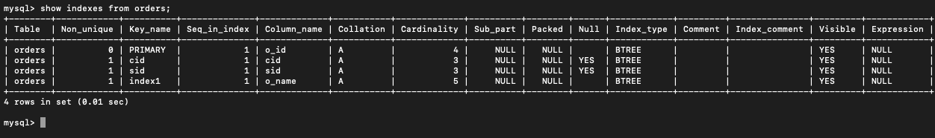

Ques9 Find the order number, sale person name, along with the customer to whom that order belongs to

